**Government Arts & Science College, Calicut**

**Palliative Care Unit**

**Activity report for the year 2021-22**

Teacher Coordinator : Dr. Muneer C.P (Dept. of Chemistry)

Members: Rejla (Dept. of Hindi), Subha(Dept. of Commerce), Dr. Sonia E.Pa(Dept. of Malayalam)

Student Coordinators : Anaswara S.L II B.Sc Physics & Jishnu K II B.Sc Maths

1. **World Blood Donor Day**

An online campaign was organized on June 14 to spread the message of importance of blood donation.

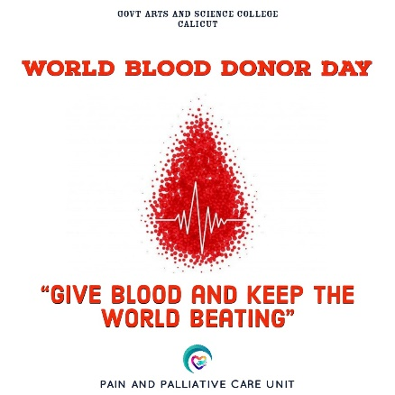

1. **Selection of new student coordinators**

In an online meeting of palliative volunteers held on 16-11-2021, Anaswara II B.Sc Physics & Jishnu II B.Sc Maths were selected as the new student coordinators for the year 2021-22.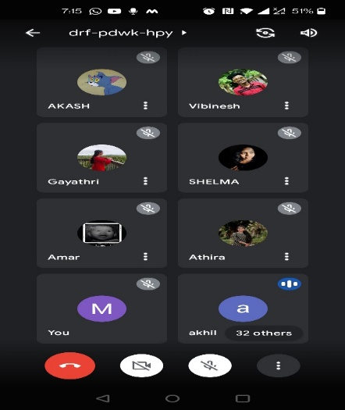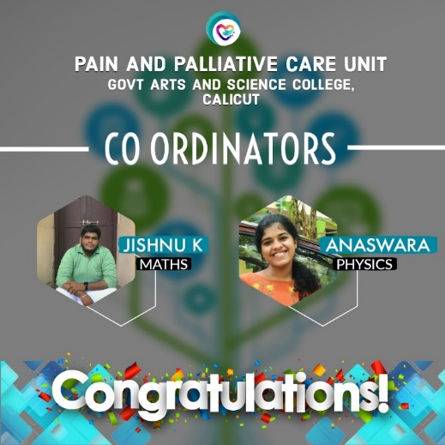

1. **Medicare**

In association with Aster MIMS, a free health check-up campaign was organized for students and staff on 7.10.2022. Many students and staff utilized the facility.

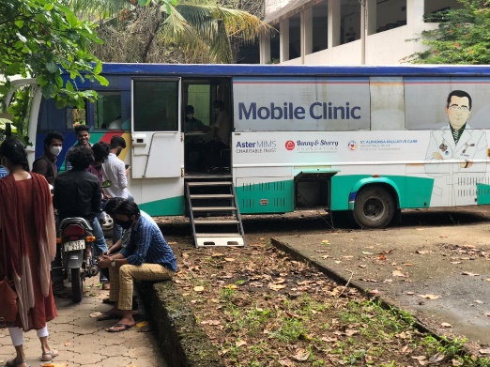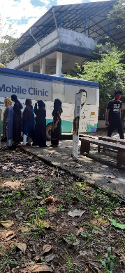

1. **Enrolment of new volunteers**

New volunteers were enrolled from first year UG classes on 7-12-2021.

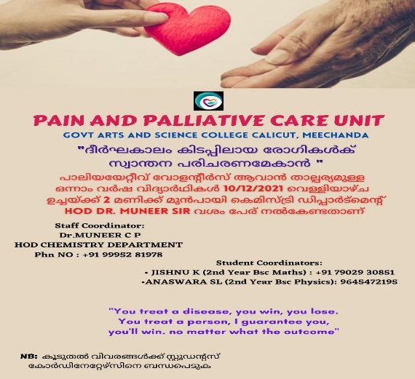

1. **Orientation Programme**

The orientation class for second year volunteers was held on 29.11.2021 at in the seminar hall. The Principal inaugurated the function. Palliative care trainer Mr. Praveen M.G took a very effective class on palliative care. Another orientation class was arranged for the new volunteers from first year classes on 14.1.2022.

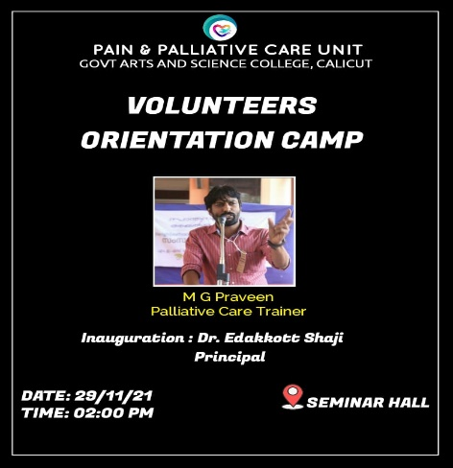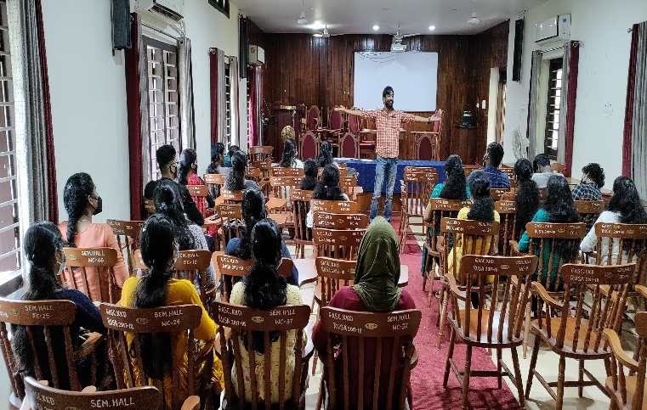

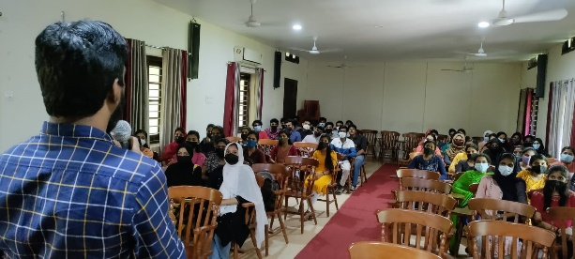

1. **World Palliative Day**

World Palliative Day was observed on October 9. Various competitions were organized among students of different departments on the occasion. Our volunteers attended the volunteers meet organized by Daya Palliative, Areekkad on 10.10.2022, in connection with world palliative day.

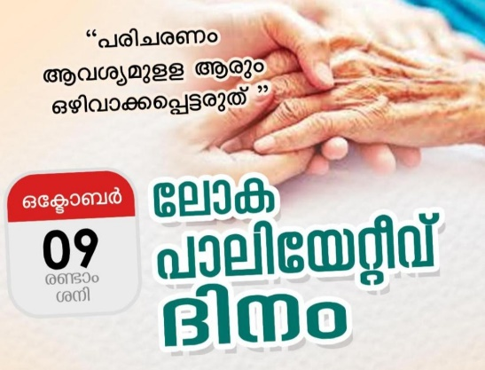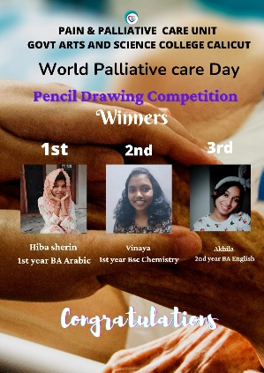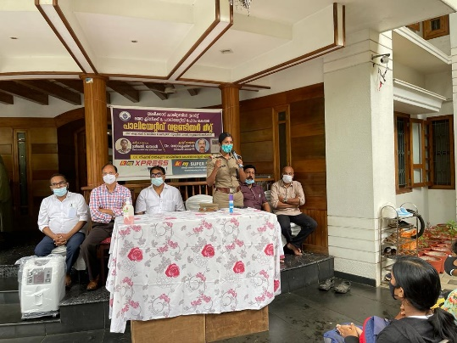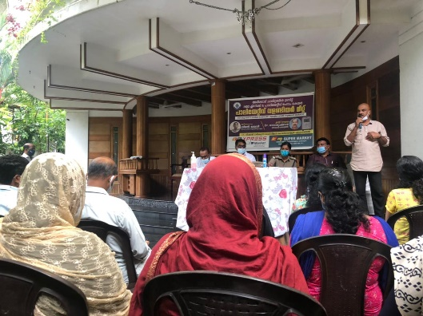

1. **Cake Fest**

Our volunteers associated with Institute of Palliative Medicine, Calicut Medical College in the fund-raising campaign held in December 2022 named Cake fest. Hundreds of cakes were purchased costing about Rs. 30000/- and distributed in the campus among students and teachers.

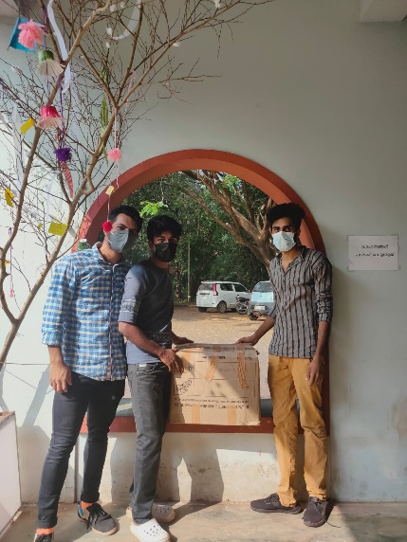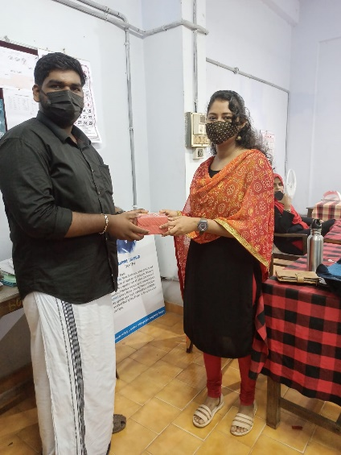

1. **Workshop on Palliative Care**

Our volunteers attended the workshop on palliative care organized by Daya Palliative , Areekkad on 27.12.2022.

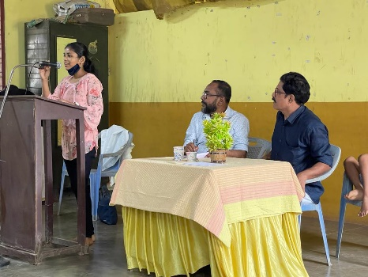 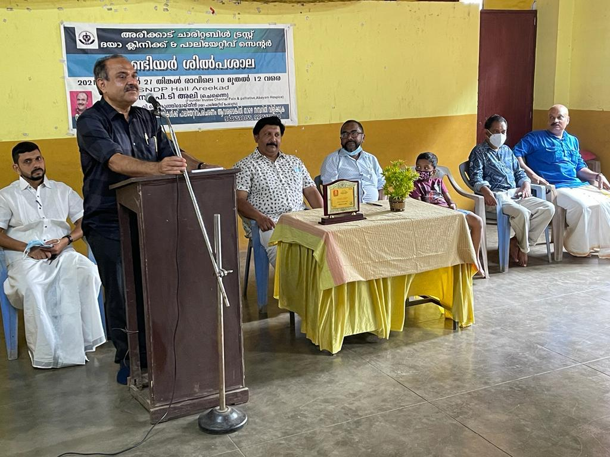

1. **Palliative Day ( January 15)**

Palliative Day was observed on January 15 by the unit. Our volunteers attended the programme organized by Daya Palliative, Areekkad. Also participated the home care visit. Our volunteers also participated in the message rally organized on the same day. A pledge was taken on the occasion.

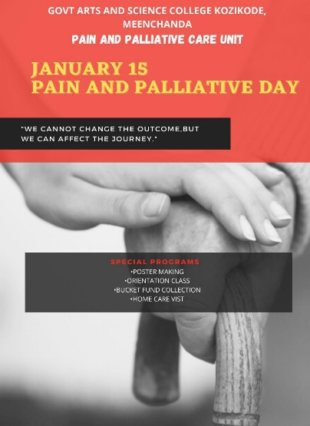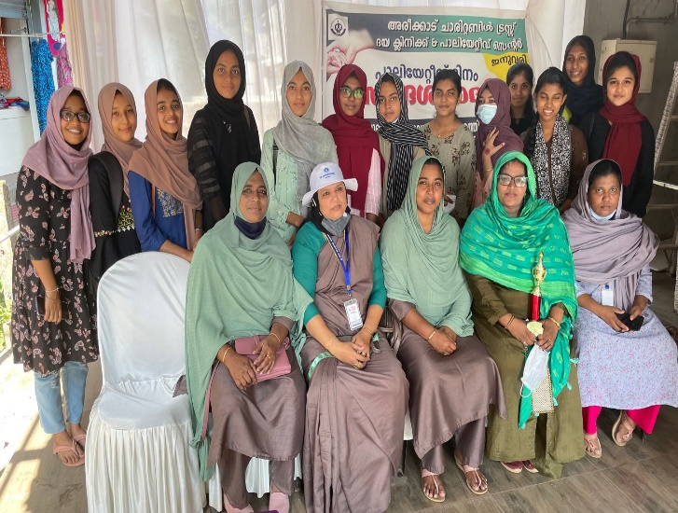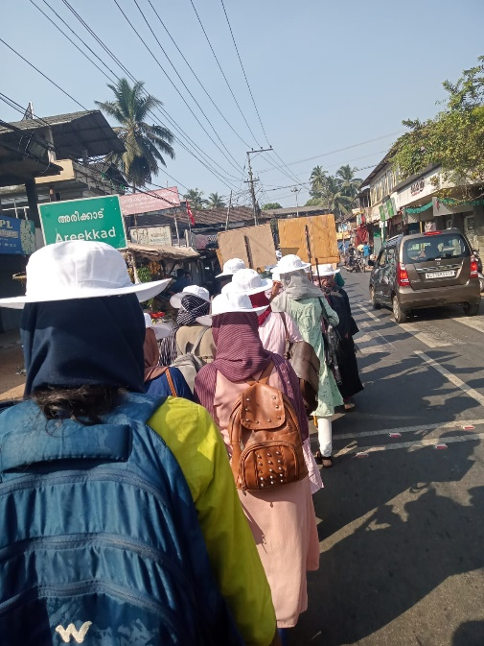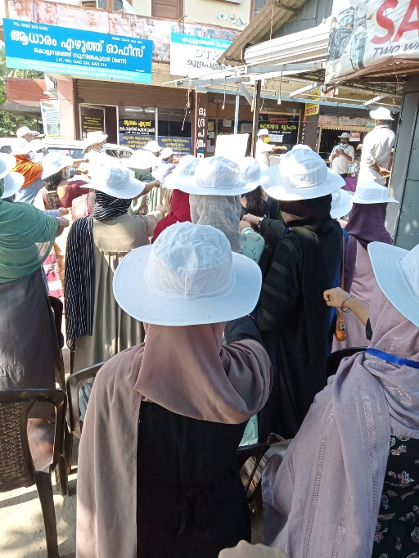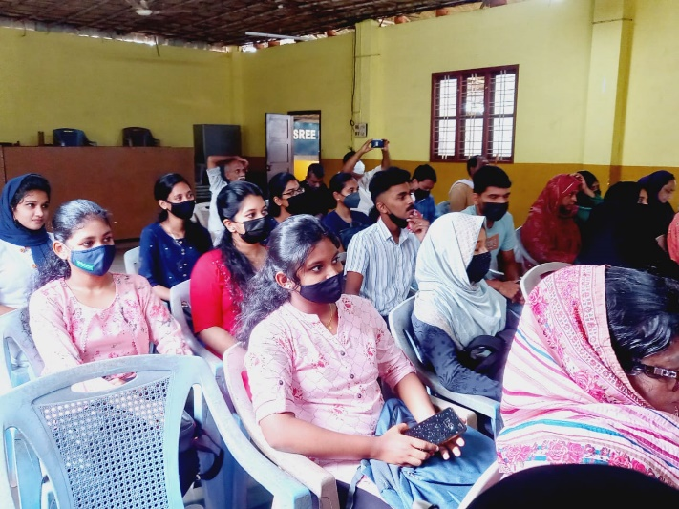

Dr. Muneer C.P

Coordinator

Palliative Care Unit

Govt. Arts & Science College, Calicut